**Developed by**

1. **Deyaninta Ekabriela Permata**
2. **Christian Frans Mukuan**
3. **Mufadhal Faraz Addhifa**



**PROJECT ON**

*Implementation of Information Technology in Teacher’s Room*

.

Batch Code : 1CC6

Start Date : September 19, 2019

End Date : October 08, 2019

Name of Faculty : Devi Afrilia Sinikite

Names of Developer :

1. Deyaninta Ekabriela Permata
2. Christian Frans Mukuan
3. Mufadhal Faraz Addhifa

Date of Submission : <Submission date>

**Implementation of Information Technology in Teacher’s Room**

.

**CERTIFICATE**

This is to certify that this report titled “Implementation of Information Technology in Teacher’s Room” embodies the original work done by Deyaninta Ekabriela Permata, Christian Frans Mukuan and Mufadhal Faraz Addhifa. Project in partial fulfillment of their course requirement at NIIT.

Coordinator:

Devi Afrilia Sinikite



.

First of all, thanks to Allah SWT because we can complete this Project task both in the form of a presentation. We want to deliver sincere especially for Ms. Devi Afrilia Sinikite faculty and another faculty who always help. Thank you also to fellow students who have supported, and also thank you for being fellow workers in the education at CCIT-FTUI.

The Project paper entitled 'Implementation of Information Technology in Teacher’s Room' the writers submits as Project's 2019 task requirements.

The hope of the writers hopefully this paper can be useful for all so that it can add knowledge and insight. The writers realize that this paper is far from perfect. Therefore, the writers expect all suggestions and criticisms from readers who are constructive for the perfection of this paper.

Depok, September 2019

Writers

**ACKNOWLEDGEMENT**

.

Teacher’s room is a room that exist on the educational institutions until now the network in the teacher’s room does not meet the needs form teachers to access another data instead of his or her own data.

In this project we want to make the teacher’s feel more facilitated with the technology nowadays. With this situation, the teacher’s do not really need any extra storage device, such as external hard disk, flash drive, micro SD, and the others to transfer the data that the device have. With the network facilities that meet the needs in the teacher’s room, teachers can send the data to the to another teacher’s PC with just connect their PC in the same network. The teacher’s task will be easier to print out any documents by connecting their PCs with the printer so the data will be printed out.

With this technology teacher’s task will be easier in many aspects such as data transfer, print out a document, filling student's grades, student attendance, and many more.

**BACKGROUND**

.

**System Summary :**

In this project, we will be designing a network architecture for “Teacher’s room “. The Network Architecture will be designed for the teachers to do many tasks. The Project used 1 room including server and 17 computers divided into 4 booths.

The topology that we used :

STAR TOPOLOGY



Features of Star Topology :

1. It is designed to look very similar to a star with a central core and many systems connected directly to that core.
2. It does have its own limitations but there are effective ways of working around them.

Advantages of Star Topology :

1. A sent signal reaches the intended destination after passing through no more than 3-4 devices and 2-3 links.
2. Easy to connect new nodes or devices. In star topology, new nodes can be added easily without affecting the rest of the network. Similarly, components can also be removed easily.
3. Failure of one node or link does not affect the rest of the network. At the same time its easy to detect the failure and troubleshoot it.

Disadvantages of Star Topology :

1. Too much dependency on a central device has its own drawbacks. If it fails the whole network goes down.
2. The use of the hub, a router or a switch as a central device increases the overall cost of the network.
3. Performance and as well number of nodes that can be added in such topology is depended on the capacity of the central device.

**SYSTEM ANALYSIS**

The Network Architecture Type that we used :

CLIENT – SERVER



Features of Client – Server :

1. It uses the same communication protocol
2. The server is generally capable of serving multiple clients simultaneously.

Advantages of Client – Server :

1. Improved Data Sharing
2. Integration of Services
3. Shared Resources Amongst Different Platforms

Disadvantages of Client – Server :

1. Overloaded Servers
2. Impact of Centralized Architecture

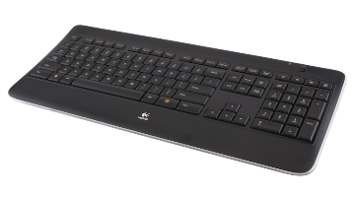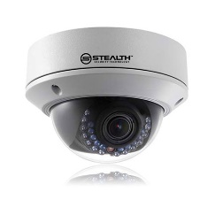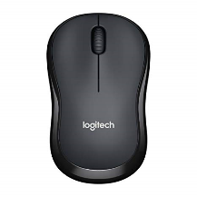

Hardware refers to the physical elements of a computer. This is also sometime called the machinery or the equipment of the computer. Examples of hardware in a computer are the keyboard, the monitor, the mouse and the central processing unit.

In computing, an input device is any hardware device that sends data to a computer, allowing you to interact with and control it.

1. There are the units of input device :

|  |  |  |  |
| --- | --- | --- | --- |
| **UNITS** | **FUNCTION** | **TYPE** | **SPECIFICATION** |
|  | It is one of the most important parts of a computer which is used to enter commands, text, numerical data and other types of data. | Logitech K800 | Charger Keyboard  Backlit Keyboard  Silent Keyboard  Wireless Keyboard |
|  | A computer mouse enables its user to move a cursor smoothly and intuitively across a two-dimensional plane. | Logitech M220 | 9,9 cm x 6 cm x 3,9 cm, wireless mouse, 1 x AA battery details |
|  | CCTV is most commonly used for surveillance. | Hikvision DS-2CE56DOT-IRP | 1920 x 1080 resolution.  Video frame rate up to 1080p@30fps.  Suitable in all weather |

**HARDWARE SPECIFICATION**

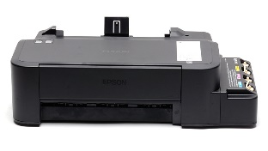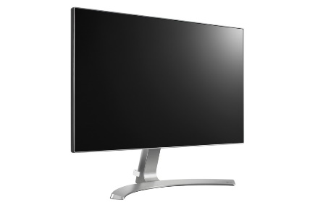 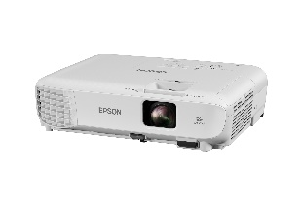k

In computing, an output device is any hardware device that receives data from a computer, usually for display, projection, or physical reproduction.

1. There are the units of output device :

|  |  |  |  |
| --- | --- | --- | --- |
| **UNITS** | **FUNCTION** | **TYPE** | **SPECIFICATION** |
|  | A projector is an output device that can take images generated by a computer | Epson EBW05 | Lumens 3300, Resolution (Native) WXGA, 1280 x 800, Throw Ratio 1.30-1.56, Contrast 15,000, LCD, HDMI Inputs: 1, Lamp Life (Est.): 10000 |
|  | To display video and graphic information generated from a computer through a device called a graphics card (VGA Card). | LG 24MP88HM-S | Full HD  (1080p) - 24"  Brightness 250 nit  Display Colors 16.7M |
|  | A printer is a device that accepts text and graphic output from a computer and transfers the information to paper | Epson L120 | High-yield ink bottles, Print speed up to 8.5ipm for black-and-white and 4.5ipm for color, Compact Size |
|  | To display the monitor display to projector | VAG-B04 15M | 15 M length  Oxygen Free Copper  Double magnets rings + alumunium foil  Diameter 7.5 mm  High Resolution |

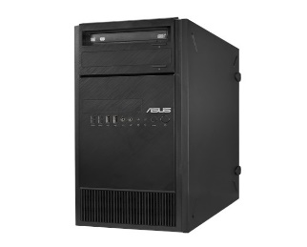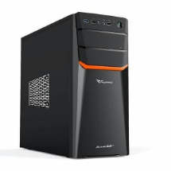 .k

1. There are the units of PC :

|  |  |  |  |
| --- | --- | --- | --- |
| **UNITS** | **FUNCTION** | **TYPE** | **SPECIFICATION** |
|  | This Server-PC provides functionality for other programs or devices, called "clients". | ASUS TS110-E8-PI4 310107 | E3-1220v3 3.1GHz Turbo 3.5 GHz 8MB L3 Cache  3.1 GHz Turbo 3.5 GHz 8MB  2x4 GB DDR3 ECC  1TB SATA 7.2Krpm Xtra Endurance HDD  2 Intel I210AT Gigabit LAN  x16 GPU Card Supported  1 PSU 300 Watt 80+ |
|  | A client is a piece of computer hardware or software that accesses a service made available by a server. | Assembly PC | *Motherboard H55  *Proc Intel Core i5 650 (Cache 4M, 3,20 GHz) socket 1156  *HDD Seagate 500GB  *Memory DDR3 8GB (4X2) PC-12800  *VGA Card Integrated Onboard  *Sound Card + Lan Card On Board  *Casing ATX Azzura  *PSU Azzura 450 Watt |

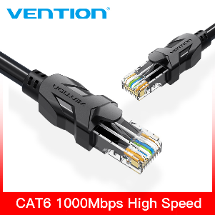 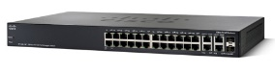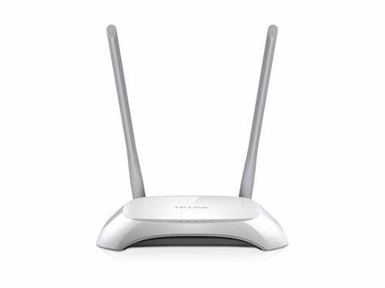

1. There are the units of network device :

|  |  |  |  |
| --- | --- | --- | --- |
| **UNITS** | **FUNCTION** | **TYPE** | **SPECIFICATION** |
|  | A modem is an external or internal device that function is to transmit digital data over communication lines | TP – LINK WR840N | 300Mbps wireless transmission rate  Supports Access Point mode to create a new Wi-Fi access point  Supports Range Extender mode to boost the existing wireless coverage in your room  4 10/100Mbps LAN PORTS |
|  | For connecting all device at the same network, connecting client – server – modem router – printer. | Cisco SF300 | The SF300 / SG300 series switches all have a 8 Mb packet buffer which is aggregated/dynamically shared across all ports. The switch fabric has a 12.8 Gbps peak capacity. The SF300-24P can switch 9.52 mpps (millions of packets per second, 64 bytes packet size). |
|  | Cable to transfer data between client – server | Vention RJ45 Cat6 | Flat Gigabit UTP  High speed data transmission rate (1 Gbps)  Wire Structure : Straight, Twisted Pair |

* System Software

|  |  |
| --- | --- |
| Operating System | Windows 10 Pro |
| Network Operating System | Windows Server 2012 |

* Application Software

|  |  |
| --- | --- |
| Word Processing Software | 1. Microsoft Word 2. Sticky Notes |
| Spreadsheet Software | 1. Microsoft Excel |
| Multimedia Software | 1. VLC |
| Presentation Software | 1. Microsoft Power Point |
| Education Software | 1. Edmodo |
| Content Access Software | 1. Google Chrome |

**SOFTWARE SPECIFICATION**

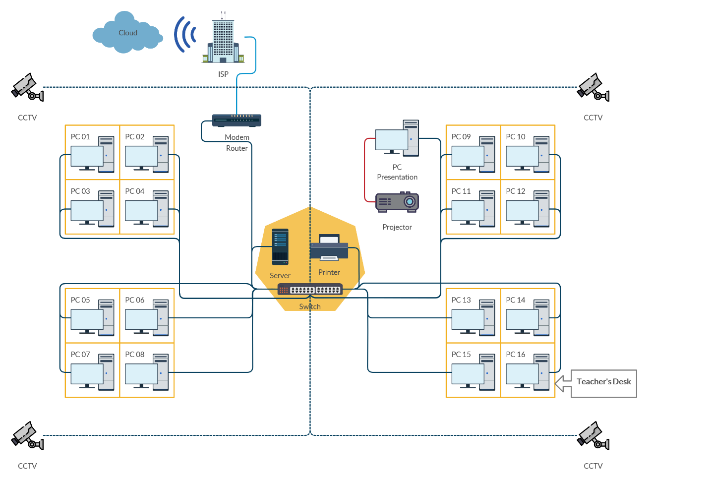 k

**NETWORK TOPOLOGY DESIGN**

|  |  |  |  |  |
| --- | --- | --- | --- | --- |
| **No** | **Device** | **Price** | **Quantity** | **Total** |
|  | Logitech Keyboard K360 | Rp. 1,000,000 | 17 pcs | Rp. 17,000,000 |
|  | Logitech Mouse M220 | Rp. 100,000 | 17 pcs | Rp. 1,700,000 |
|  | Hikvision CCTV DS-2CE56DOT-IRP | Rp. 270,000 | 4 pcs | Rp. 1,080,000 |
|  | Epson Projector EBW05 | Rp. 6,400,000 | 1 pcs | Rp. 6,400,000 |
|  | LG Monitor 24MP88HM-S | Rp. 2,500,000 | 17 pcs | Rp. 42,500,000 |
|  | Epson Printer L120 | Rp. 1,600,000 | 1 pcs | Rp. 1,600,000 |
|  | ASUS Server TS110-E8-PI4 310107 | Rp. 12,400,000 | 1 pcs | Rp. 12,400,000 |
|  | Assembly PC Core i5 | Rp. 2,200,000 | 17 pcs | Rp. 37,400,000 |
|  | TP – LINK WR840N Modem router | Rp. 280,000 | 1 pcs | Rp. 280,000 |
|  | Cisco Switch SF300 | Rp. 6,400,000 | 1 pcs | Rp. 6,400,000 |
|  | Vention RJ45 Cat6 | Rp. 140,000 / 15 m | 60 m | Rp. 560,000 |
|  | VAG-B04 15M | Rp. 190,000 | 1 pcs | Rp. 190,000 |
|  | Windows 10 Pro License | Rp. 1,250,000 | 17 licenses | Rp. 21,250,000 |
|  | Windows Server 2012 | Rp. 3,500,000 | 1 pcs | Rp. 3,500,000 |
|  | Microsoft Office 2016 Professional Plus | Rp. 1,500,000 | 17 licenses | Rp. 25,500,000 |
| **TOTAL BUDGET** | | | | **Rp. 177,760,000‬** |

**BUDGET**